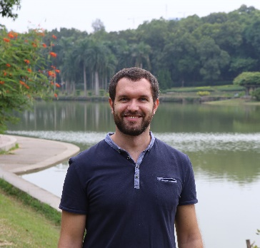**Dr. Massimiliano Galluzzi** is Associate Researcher in Shenzhen Institute of Advanced Technology, Chinese Academy of Science. Massimiliano Galluzzi received a Ph.D. in Physics, Astrophysics and Applied Physics from the University of Milan (Italy) in 2014. His research is mainly focused on Atomic Force Microscopy (AFM) applied to biophysical investigations, nanobiomechanics and biomaterial interactions. His interest involves mechanical properties of living cells, complex protein-biomembranes mechanics and force sensing in biology and material sciences. He is managing a team of young scientists focusing on imaging technologies with emphasis for microplastic interaction with macrophages, photocatalysis, biosensing and single molecule force spectroscopy. The team is supported by 3 National Science Foundation of China funding, various provincial funding, and Youth Promotion Association from CAS. He won Excellent Youth from MOST, Guangdong Excellent Postdoctoral Introduction and a JSPS fellowship in Tokyo University where he is visiting professor.

**Title:** **Atomic Force Microscopy Nanomechanics for the Detection of Microplastics in Ground Water: Study Case from Dasha River, Shenzhen, Guangdong.**

Massimiliano Galluzzi*, Xun Li, Michele Lancia, Stefano Viaroli

Lab of Inflammation and Vaccine, Shenzhen Institutes of Advanced Technology, Chinese Academy of Sciences, Shenzhen 518055, P.R. China

*Email: galluzzi@siat.ac.cn

Microplastic pollution is a severe environmental issue with potential impacts on human health. Despite the worldwide diffusion of plastic debris in the environment, the effective characterization of microplastics (MPs) in groundwater is still under debate. During the seepage processes throughout the aquifers, subsoils have the capacity to block the larger MPs particles, while the finer fragments are difficult to detect with the standard techniques. Here, we propose a new protocol based on multifrequency Atomic Force Microscopy (AFM) and fluorescence methods, to detect and quantify plastic particles from microscale down to nanoscale according to their nanomechanical properties. The proposed methodology was tested on reconstituted MPs to distinguish potential false-positive detection of MPs in natural samples. Subsequently, our protocol was applied on urban groundwater sampled in Dasha river within an Asian megacity (Shenzhen, China). MPs were detected and characterized in three groundwater samples. This methodology represents an advancement in the mechanical characterization of MPs that can circulate in the aquifers but are difficult to detect via traditional analytical methods.